**EX NO:14 WEB SERVICES**

**DATE:**

**AIM:**

To Create a web service application that allows users to update customer information in a database,

and returns a list of customers. Use Java, JAX-RS, and JDBC to connect to the database. Create

a web service client in Java to invoke the web service.

Note: JAX-RS stands for Java API for RESTful Web Services. It is a Java programming

language API that provides support for creating web services that follow the REST

architectural style..

**ALGORITHM:**

**Step 1**: Start: Create a Java class named db annotated with @WebService.

**Step 2**: Define a method insert annotated with @WebMethod. It accepts parameters id, name, and amount for inserting records into the database.

**Step 3**: Within the insert method, establish a connection to the database using JDBC.

**Step 4**: Execute an SQL insert query to add the new record to the database.

**Step 5:** Execute a select query to retrieve all records from the customer table and construct a string representation of the records.

**Step 6**: Define a method edit annotated with @WebMethod to update existing records in the database.

**Step 7**: Inside the edit method, execute an SQL update query to modify the record with the provided id.

**Step 8:** Return a string containing the result of the operation (success or failure) along with the updated list of records.

**Step 9:** Stop.

**SOURCE CODE:**

**--db.java**

package demo;

import java.sql.*;

import javax.jws.WebService;

import javax.jws.WebMethod;

import javax.jws.WebParam;

@WebService(serviceName = "db")

public class db

{

@WebMethod(operationName = "insert")

public String insert(@WebParam(name = "id") int id, @WebParam(name = "name") String name, @WebParam(name = "amount") int amount)

{

StringBuilder result = new StringBuilder();

result.append("The new record for "+name+" is inserted successfully\n\n");

result.append("ID\t").append("Name\t").append("Total\n");

result.append("---\t").append("-----\t").append("------\n");

try{

Connection c=DriverManager.getConnection("jdbc:derby://localhost:1527/vishwa");

Statement st=c.createStatement();

st.executeUpdate("INSERT INTO customer VALUES("+id+",'"+name+"',"+amount+")");

ResultSet rs=st.executeQuery("Select * from customer");

while(rs.next())

{

int cid=rs.getInt("id");

String nam=rs.getString("name");

int tot=rs.getInt("total");

result.append(cid+"\t").append(nam+"\t").append(tot+"\n");

}

st.close();

c.close();

}

catch(SQLException e)

{

e.printStackTrace();

}

return result.toString();

}

@WebMethod(operationName = "edit")

public String edit(@WebParam(name = "id") int id, @WebParam(name = "name") String name, @WebParam(name = "amount") int amount)

{

StringBuilder result = new StringBuilder();

try {

Connection c = DriverManager.getConnection("jdbc:derby://localhost:1527/vishwa");

Statement st=c.createStatement();

String updateQuery = "UPDATE customer SET name='" + name + "', total=" + amount + " WHERE id=" + id;

int rowsAffected = st.executeUpdate(updateQuery);

if (rowsAffected > 0) {

result.append("The customer record with ID ").append(id).append(" is updated successfully.\n\n");

result.append("ID\t").append("Name\t").append("Total\n");

result.append("---\t").append("-----\t").append("------\n");

ResultSet rs=st.executeQuery("Select * from customer");

while(rs.next())

{

int cid=rs.getInt("id");

String nam=rs.getString("name");

int tot=rs.getInt("total");

result.append(cid+"\t").append(nam+"\t").append(tot+"\n");

}

}

else {

result.append("Failed to update the customer record with ID ").append(id).append(".\n\n");

}

st.close();

c.close();

}

catch (SQLException e) {

e.printStackTrace();

result.append("Error occurred while updating the customer record.\n\n");

}

return result.toString();

}

}

**OUTPUT:**

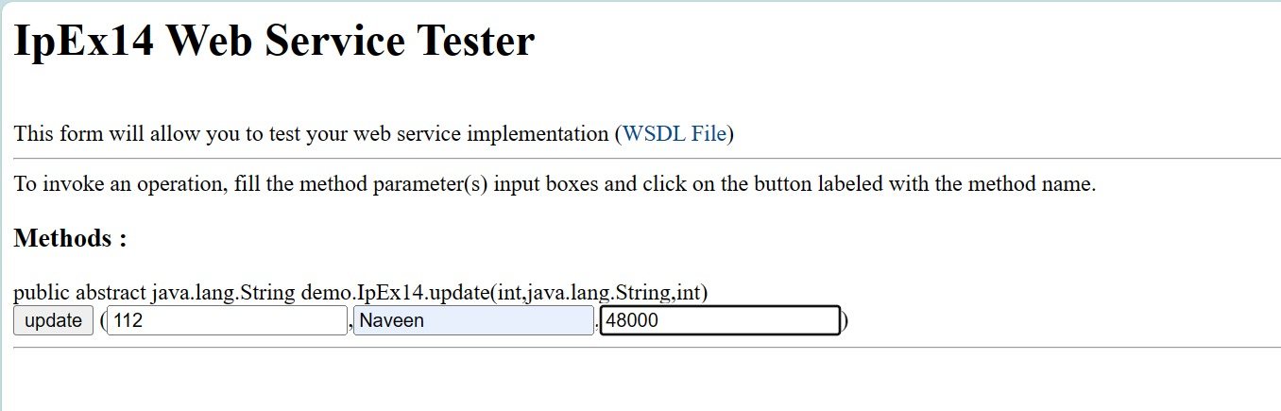

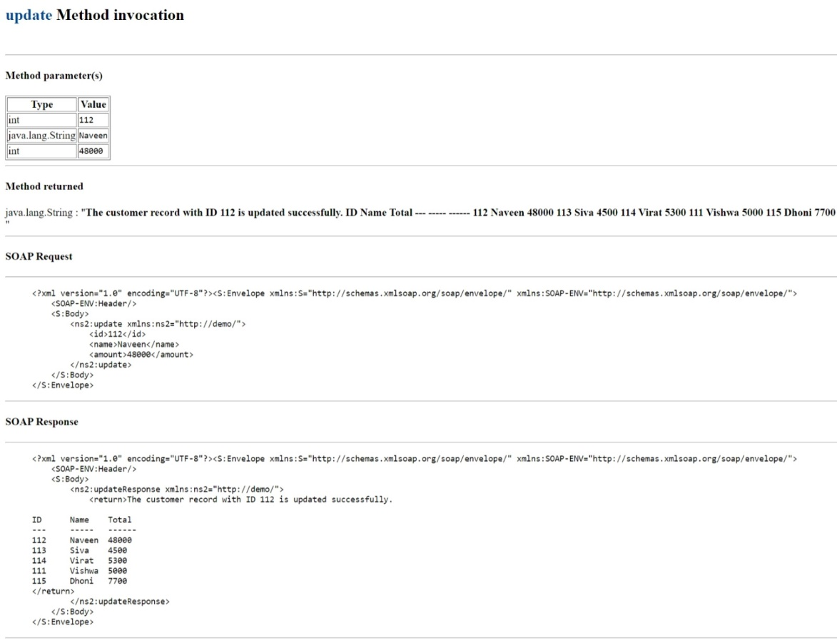

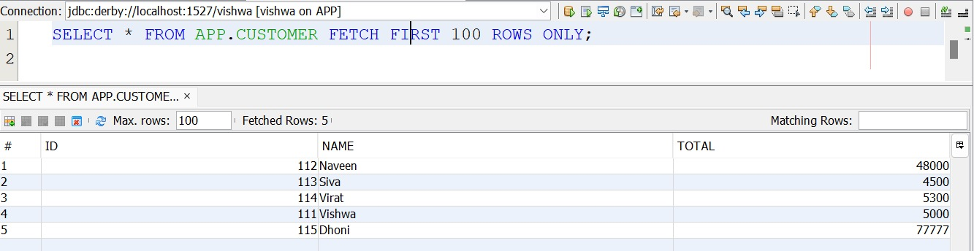

|  |  |
| --- | --- |
| **Code & Output (20)** |  |
| **Quiz (5)** |  |
| **Timely Submission (5)** |  |
| **Total (30)** |  |
| **Initial** |  |

**RESULT:**

Thus the execution of code for a given problem statement of Webservices by using java has been executed and the output is verified successfully.